Creating Custom Code Panels using NetBeans

- Install NetBeans, http://www.netbeans.org
- Create a new “Java Application”
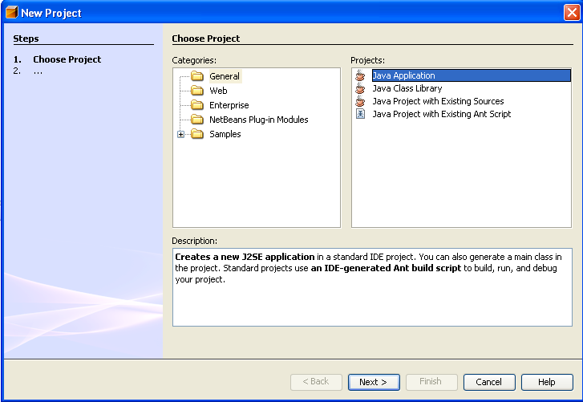
- Create a new “JPanel Form”
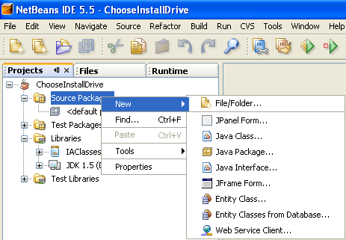
- Configure New “JPanel Form”
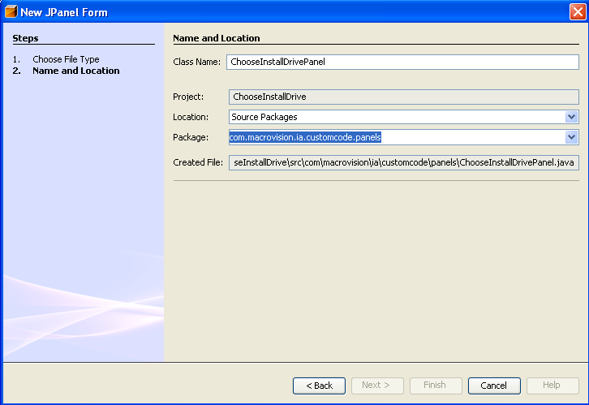
- Layout Panel
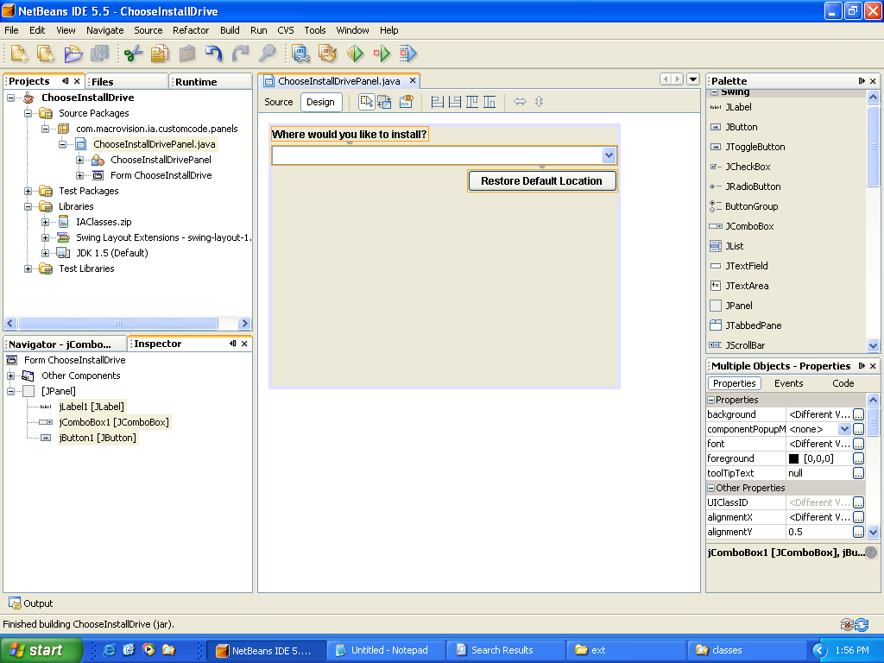
- Click on the Source Tab
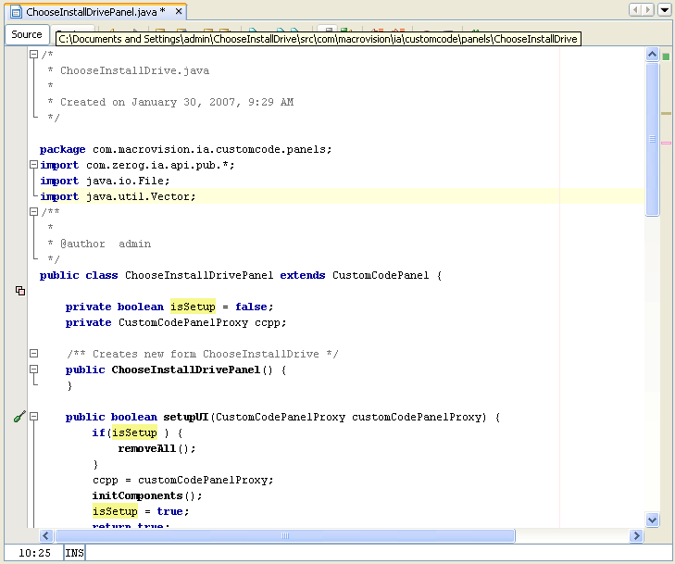
- Add “import com.zerog.ia.api.pub.*” to list of imports
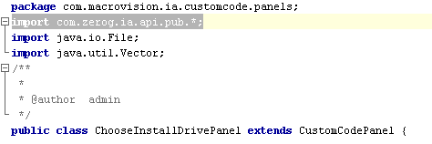
- Change “extends JPanel” to “extends CustomCodePanel”
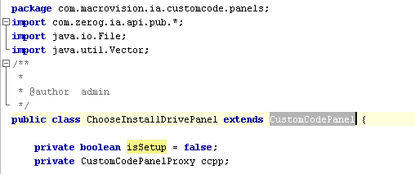
- Click Source->Override Methods…
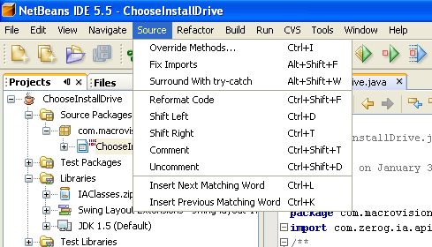
- Select setupUI,okToContinue,getTitle (The others are optional).
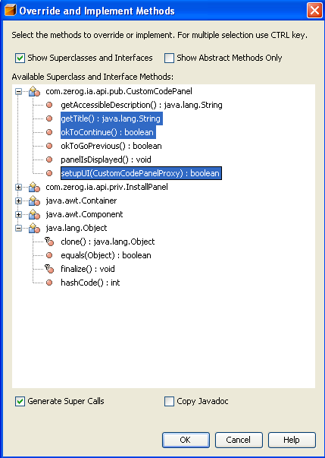
- Move initComponents () method to setupUI. Set setupUI to return true.
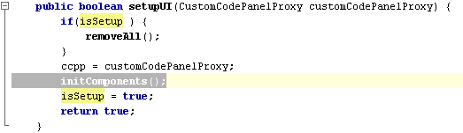
- Implement getTitle()
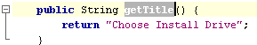
- Implement okToContinue() method
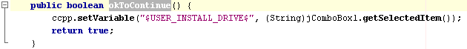
- Add Custom Code Panel action to InstallAnywhere project
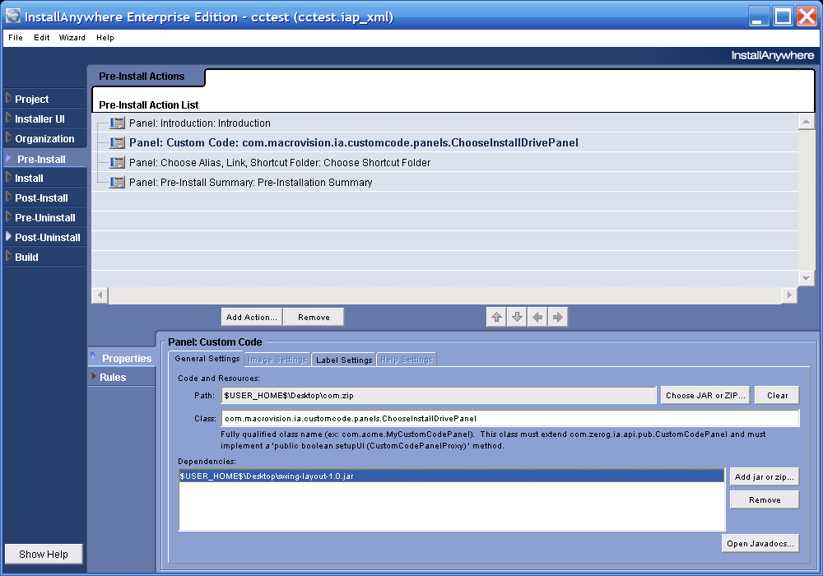
Add swing-layout-1.0.jar as a Dependency.
You can find it in <NetBeans Install Folder>\platform6\modules\ext
- Package & Execute
